The file "student data for EDA.csv" contains exam, homework, and project scores for 119
students.
-Using R, perform exploratory data analysis. Calculate summary statistics for the data
(min, max, mean, standard deviation).
-Create histograms, run (line) charts, and scatter plots for each column (exam, homework, and project).
-Clearly and specifically, identify any potential information quality issues in the data and provide the output the identified the issue.
-Include your R program and the visualization or summary statistics that identified the issue.

```{r}
# EDA in R (full script)
df <-read.csv("C:/Users/tyler/OneDrive/Documents/GitHub/work_to_show/Classes Spring 2026/BDA Spring 26/student data for EDA.csv",header=TRUE) # FORWARD SLASH AND HEADER TRUE IF HAVE COLUMN NAMES
# column names
colnames(df) # "Student" "Exam" "Homework" "Project"
#head of the data
head(df)
#summary stats
summary(df$Student)
summary(df$Exam)
summary(df$Homework)
summary(df$Project)
'''
> summary(df$Student)
Min. 1st Qu. Median Mean 3rd Qu. Max.
1.0 30.5 60.0 60.0 89.5 119.0
> summary(df$Exam)
Min. 1st Qu. Median Mean 3rd Qu. Max.
30.82 66.14 79.39 75.65 90.19 99.40
> summary(df$Homework)
Min. 1st Qu. Median Mean 3rd Qu. Max.
-77.73 73.03 88.34 80.80 100.00 100.00
> summary(df$Project)
Min. 1st Qu. Median Mean 3rd Qu. Max.
29.56 73.34 87.18 82.17 99.17 100.00
'''
# mean of columns
mean(df$Student)
mean(df$Exam)
mean(df$Homework)
mean(df$Project)
'''
> mean(df$Student)
[1] 60
> mean(df$Exam)
[1] 75.65008
> mean(df$Homework)
[1] 80.79866
> mean(df$Project)
[1] 82.16706
'''
# stand dev of columns
sd(df$Student)
sd(df$Exam)
sd(df$Homework)
sd(df$Project)
'''
> sd(df$Student)
[1] 34.49638
> sd(df$Exam)
[1] 18.20467
> sd(df$Homework)
[1] 23.82734
> sd(df$Project)
[1] 18.30348
'''
# finding the regression line
mean(df$Student)+3*sd(df$Student)
mean(df$Student)-3*sd(df$Student)
mean(df$Exam)+3*sd(df$Exam)
mean(df$Exam)-3*sd(df$Exam)
mean(df$Homework)+3*sd(df$Homework)
mean(df$Homework)-3*sd(df$Homework)
mean(df$Project)+3*sd(df$Project)
mean(df$Project)-3*sd(df$Project)
'''
[1] 163.4891
[1] -43.48913
[1] 130.2641
[1] 21.03608
[1] 152.2807
[1] 9.316634
[1] 137.0775
[1] 27.25663
'''
#histogram
hist(df$Student)
hist(df$Exam)
hist(df$Homework) # some input is wrong -77 value
hist(df$Project)
#plot with ab line
plot(df$Student,type="b")
abline(h=mean(df$Student))

plot(df$Exam,type="b")
abline(h=mean(df$Exam))

plot(df$Homework,type="b") # extremely low outlier
abline(h=mean(df$Student))

plot(df$Project,type="b")
abline(h=mean(df$Exam))
#correlation
cor(df$Student, df$Exam)
plot(df$Student, df$Exam)

cor(df$Student, df$Homework) # outlier shows
plot(df$Student, df$Homework)

cor(df$Student, df$Project)
plot(df$Student, df$Project)

cor(df$Exam, df$Homework) # outlier shows
plot(df$Exam, df$Homework)

cor(df$Exam, df$Project)
plot(df$Exam, df$Project)

cor(df$Homework, df$Project) # outlier shows
plot(df$Homework, df$Project)
```
Should not be a bar <0. 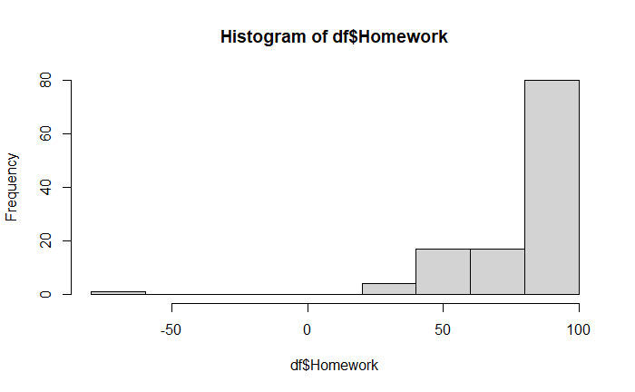should not be a plot <0 makes me think of entry error. 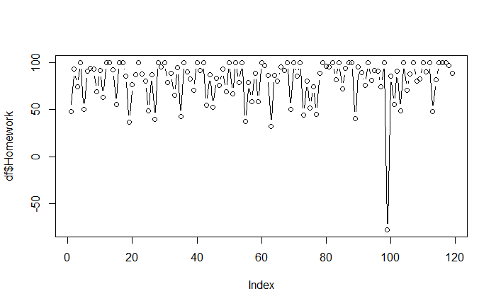once again <0 entry. Has to be entry error for homework. 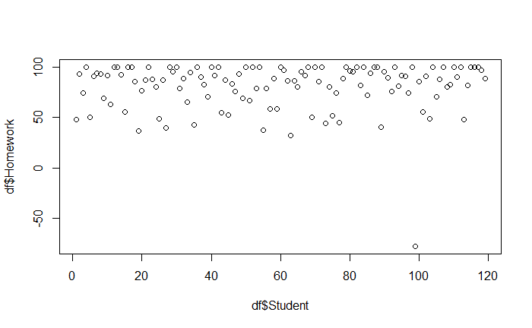line does not correlate has an outlier with the homework once again. 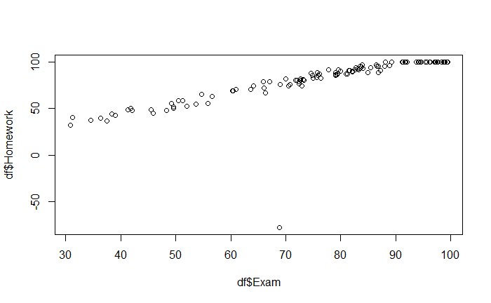homework outler appears once again has to be entry error. Looking at the data it says the value is -77, and it is the only one. 